IWF BC Foundation Board of Directors

Patra de Silva (President & Chair)

Patricia Chew (Vice President)



Anna Nyarady (Secretary)



Catherine Roome (Treasurer)



Zulie Sachedina (Director)

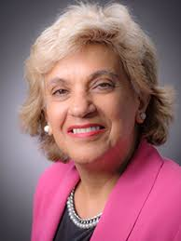

Laura Edwards (Advancement Chair)

